Cài đặt:

**1) Install Promethues**

|  |  |
| --- | --- |
| [1] | Install [prometheus] package that includes Prometheus Server function and [prometheus-node-exporter] package that includes function to get general resource on the System like CPU or Memory usage. |



|  |  |
| --- | --- |
| [2] | Configure basic settings on prometheus.yml. |





|  |  |
| --- | --- |
| [3] | Access to the [http://ip:9090/] from a client host, Then, Prometheus Web UI is shown like follows. |

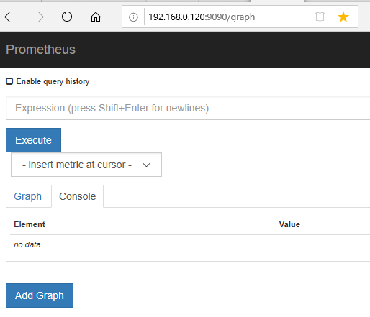

|  |  |
| --- | --- |
| [4] | To click [insert metric at cursor], there are many queries to view time series data. It's also possible to input queries directly on the input form above, by Prometheus Expression Language. |

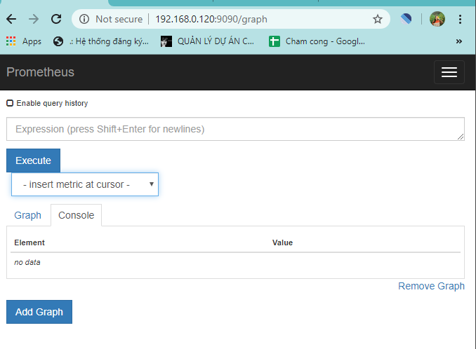

|  |  |  |  |  |  |
| --- | --- | --- | --- | --- | --- |
| |  |  | | --- | --- | | [5] | This is the state of executing [node_load5]. |      |  |  | | --- | --- | | [6] | To click [Status] - [Targets], possible to confrm status for each node. | |  |